Performance Report

By Marwan Hany

# Usage

## Main Menu

## Markerless

## Marker

# Top CPU Consumer

(based on marker scene)

From the reports it seems that scripting is consuming the highest usage

## Rendering

## Scripting

## Physics

# GC

## Marker

## Markerless

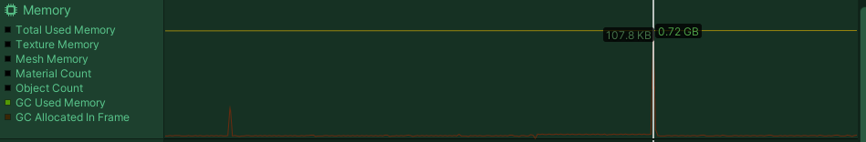

# Draw Cell

# Canvas Splitting

# Graphic Raycaster Manager

# Build Settings

